Rockchoir Phase 2

* Login :

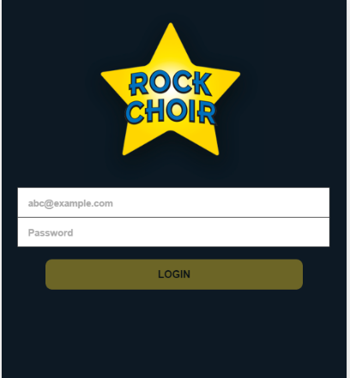

Here user able to login .

API Details :

Requested URL: https://rockchoir.magentrix.com/rest/2.0/login?un="username"&pw="password"

API Response: if login successfully we get session id other vise login fail error

* Home page :



Here we display menu list like, song list, Billing History , personal info, session calendar

*Personal Info :

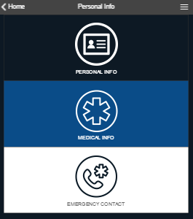

Here under Personal info we have 2 submenu like , personal info, medical info, emergency info

a) personal Info :

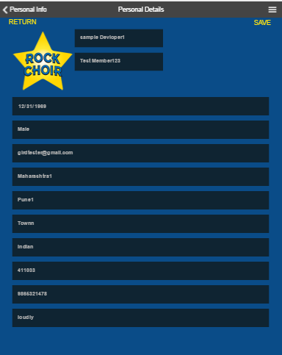

here we will display personal information of logged user, here we also provide update personal details facility.

API Details :

Requested URL: https://rockchoir.magentrix.com/rest/2.0/query?q=FROM Force.Force__Contact WHERE Email="Email"

API Response: Here we get User Details.

API Details to Update Personal Details :

Requested URL: https://rockchoir.magentrix.com/rest/2.0/edit?e=Force__Contact

with list of data to update

API Response: api return flag , that indicated details updated or not

b)Medical Info :

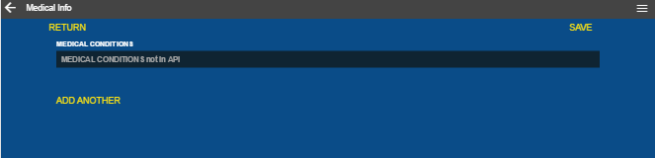

Here we will get medical info of logged user

Requested URL: https://rockchoir.magentrix.com/rest/2.0/query?q=FROM Force.Force__Contact WHERE Email="Email"

API Response: Here we get User Details.

API Details to Update Personal Details :

Requested URL: https://rockchoir.magentrix.com/rest/2.0/edit?e=Force__Contact

with list of data to update

API Response: api return flag , that indicated details updated or not

c) Emergency Contact :

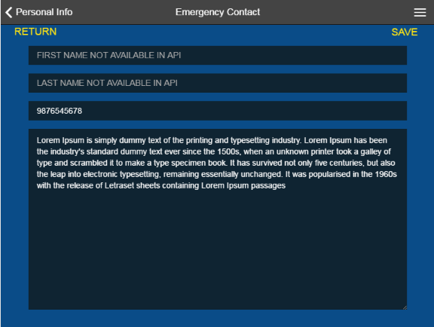

Here we will display all emergency contact details ,with update details facility .

Requested URL: https://rockchoir.magentrix.com/rest/2.0/query?q=FROM Force. 20Force__Emergency_Contact__c "

API Response: Here we get User Details.

API Details to Update Details :

Requested URL: https://rockchoir.magentrix.com/rest/2.0/edit?e= 20Force__Emergency_Contact__c

with list of data to update

API Response: api return flag , that indicated details updated or not

* Payment details :

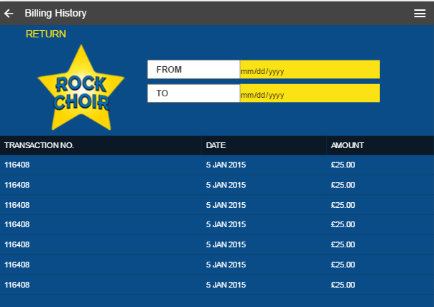

here we will display Billing history of logged user.

API Details :

Requested URL: https://rockchoir.magentrix.com/rest/2.0/ query?q=FROM Force.Force__Payment__c WHERE Status__c != "Pending"

API Response: Here we get list payment details

* Session Calendar :

Here we will display session list booked by user.

API Details :

Requested URL: https://rockchoir.magentrix.com/rest/2.0/query?q=FROM Force.Force__Attendance__c

API Response: Here we get list session of logged user

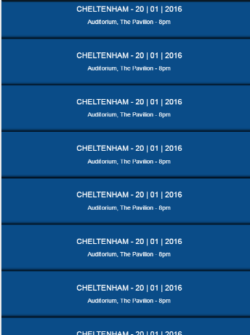

*song List :

Here we display document list

API Details :

Requested URL: https://rockchoir.magentrix.com/rest/2.0/query?q=FROM Document

API Response: Here we get list document

